RESOLUTION NO.__________

RE: CERTIFICATE OF APPROPRIATENESS UNDER THE
PROVISIONS OF THE ACT OF THE PENNSYLVANIA
LEGISLATURE 1961, JUNE 13, P.L. 282 (53
SECTION 8004) AND BETHLEHEM ORDINANCE NO.
3952 AS AMENDED.

WHEREAS, it is proposed to replace the existing sign content at 306 Brodhead Avenue.

NOW, THEREFORE, BE IT RESOLVED by the Council of the City of Bethlehem that a Certificate of Appropriateness is hereby granted for the work.

Sponsored by: (s)

(s)

ADOPTED BY COUNCIL THIS DAY OF

(s)
President of Council

ATTEST:

(s)
City Clerk

HISTORIC CONSERVATION COMMISSION

CASE # 602– It is proposed to replace the existing sign content at 306 Brodhead Avenue
OWNER/APPLICANT: Angelina M, LLC / Michelle Conrad

The Commission upon motion by Mr. Lader seconded by Mr. Traupman adopted the proposal that City Council issue a Certificate of Appropriateness for the proposed work described herein:
- The proposal to replace the existing sign content at 306 Brodhead Avenue was represented by Michelle Conrad.

- The sign will read “Shabby Chinelle’s vintage, antique, parking in rear” and have a tree graphic.

- The sign will not be internally illuminated. Gooseneck lighting may be installed above the box sign instead for illumination. Specifications and details for gooseneck lighting would need to be reviewed by the Historic Officer.

- The motion to approve the proposal was unanimously approved.

CU: cu
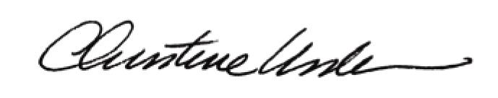

By:

Date of Meeting: November 21, 2016 Title: Historic Officer

